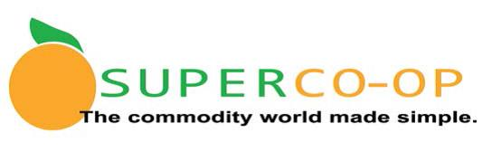

Handbook
Navigating USDA Foods as a Co-Op Member District
www.Super-Coop.org

July 1, 2019
Updates highlighted in blue

Table of Contents
Section Page
Introduction 3
Allocation of Commodity Entitlement 3
Fair Market Value 4
Annual Entitlement Expenditure Report 4
Value Pass Through 4
Rebates 5
Fee for Service (FFS) 5
Net off Invoice (NOI) 5
Substitution of USDA Foods 5
USDA Foods Direct Delivery (formerly brown box) 6
Direct Delivery Management Reports 6
USDA Foods Processing 7
Requesting Processed USDA Foods 7
Processors 8
Direct Shipment 8
Distributors 8
Product Formulation Statements (PFS) 8
Summary End Product Data Schedules (SEPDS) 8
Verification of VPT 9
Department of Defense (DoD) Fresh Produce 9
Unprocessed Fruit & Vegetable Pilot 9
Complaints 10
Proper Storage of USDA Foods 10
Super Co-Op Governance 11
Lead District 12
Administrator 13
Administrative Website 13
How to get started 14
Fee Structure 14
Responsibilities of the Member District 14
Regional Groups List 15
Annual Timeline 17
2019-20 Fee Structure 18
Direct Delivery (Brown Box) Storage Policy 19
Super Co-Op Governing Rules 21

Introduction
The USDA Foods Program provides approximately 20% of the food served in the National School Lunch Program. The USDA Foods program began in the early 1930’s as an outgrowth of federal agriculture policies designed to shore up farm prices and help American farmers suffering from the economic upheaval of the Great Depression. In current times, the program functions to support domestic nutrition programs and American agricultural producers through purchases of domestic agricultural products for use in schools and institutions.
Processing of USDA Foods allows Recipient Agencies (RAs) such as school districts to contract with commercial food processors to convert raw bulk USDA Foods into more convenient, ready-to-use end products. USDA began the processing program in 1958 to permit state distributing agencies and eligible recipient agencies to maximize the use of USDA Foods.
For more detail on how the USDA Foods Program functions and for additional information on Processing, please refer to the American Commodity Distribution Association (ACDA) School Recipient Agency (RA) Processing Handbook found on the Super Co-Op website at www.Super-Coop.org.
Allocation of Commodity Entitlement
The RA receives an annual entitlement to purchase USDA Foods. The amount of entitlement is equal to the Total Lunches Served (TLS) for the prior school year multiplied by the annual meal rate, a value per lunch as set annually by the U.S. Congress. The estimated meal rate for the 2019-20 school year is $0.3350 per reimbursable lunch meal claimed. The meal rate is adjusted annually for inflation and published in July. (2018-19 rate was $0.3425; 2017-18 rate was $0.3350; 2016-17 rate was $0.3175)
The Richard B. Russell National School Lunch Act Section 6(e) (42 U.S.C. 1755(e) requires that commodity assistance be provided at the rate of 12% of the combined value of Sections 4 & 11 lunch meal reimbursements. The published meal rate is adjusted annually to meet this requirement.
As the final TLS is not verified until the end of November each subsequent year, the Super Co-Op uses the prior year TLS and entitlement per meal value to begin the USDA Foods request process in the spring of each year. RAs should check their Super Co-Op website Dashboard in late November/early December for these updates (increase or decrease) in their annual entitlement. Please notify the Super Co-op of you disagree with your entitlement calculation.
While there is no entitlement value provided for USDA Foods in the School Breakfast Program, USDA Foods may be served in the School Breakfast Program.
RAs can utilize entitlement in three ways: direct delivery (aka brown box) which are raw commodity items delivered to your warehouse such as turkey roasts or canned peaches, processed product (raw product diverted to a manufacturer for further processing such as ground beef made into hamburger patties), Department of Defense (DoD) Produce, or the Pilot Project for Procurement of Unprocessed Fruits and Vegetables.
Fair Market Value
Each case of USDA Foods has a Fair Market Value (FMV) assigned at the time the product is delivered. Because the prices in the market place fluctuate based on many factors, the actual FMV of USDA Foods may vary throughout the year. The FMV per case is used to “charge” against your annual entitlement for the value of each USDA Food item received. You might hear the term “draw down” used to describe this process. Your entitlement balance is drawn down by the FMV or USDA Foods value, whether it is brown box, processed, or DoD produce.
Annual Entitlement Expenditure Report
At the top of your Dashboard on the Super Co-Op website, you will see the tab. This report can be used to substantiate the value of entitlement received in the school year. The report is considered accurate on July 30 for the preceding year, as distributors have 30 days to report sales of processed USDA Foods after the end of the school year.
Per California Department of Education (CDE) Management Bulletin FDP-03-2018: “In accordance with Title 2, Code of Federal Regulations (2 CFR), Part 200, Appendix VII, Item C, the CDE and the U.S. Department of Education negotiated to include food costs in the indirect cost rate. The CDE recognizes that the U.S. Department of Agriculture (USDA) Policy Memorandum SP 60-2016: Indirect Cost Guidance, instructs school food authorities (SFA) to exclude food costs from the indirect cost rate; however, the CDE negotiated restricted indirect rate supersedes this policy guidance. SFAs are instructed to follow the California School Accounting Manual (CSAM) accounting procedures on how to properly account for their food costs.” Entitlement should be booked as revenue under object code 8221 and the same value as an expense under food. Your district can charge indirect costs against this booked expense.
Super Co-Op values your USDA Foods using the following method: the cost per pound of USDA Foods using the annual prices posted by the USDA, which are found on the USDA Food Distribution Processor Material Prices web page at https://www.fns.usda.gov/fdd/processor-material-prices.
Value Pass Through
Federal law requires that RAs receive the full value of their USDA Foods. When processing, this value must be passed through to the RA by the processor or distributor. The method used to credit the RA is called the Value Pass Through (VPT). There are three primary forms of VPT, with variations in each: rebates, fee for service, and net off invoice. The VPT method is determined by the processor and approved by the State. The VPT can vary by distributor; processors are required to maintain agreements with distributors regarding VPT methods. The RA should know the VPT method to be used with the distributor, this should be outlined in your local contract with the distributor you use for processed USDA Foods.
Rebates are a method where the RA pays the “commercial” price for a processed item and submits a request for rebate to the processor, who issues a check for the value of the donated
USDA Foods used. With rebates, the processor benefits from receiving payment for the full cost of processed item until it issues payment to the RA for the value of the donated food. The distributor benefits by billing at the higher commercial price. The RA does not receive the full value of the USDA Food until it receives the rebate check. RAs should submit rebate applications monthly. Title transfers to the RA when the product is delivered, but entitlement draw down does not occur until the rebate check is issued. This is not a common practice in California.
Fee for Service (FFS) is a method where the processor bills for the costs of processing without the value of the USDA Food included in the price. Under FFS, the processor does not benefit from the value of the USDA Foods used. The effect on distributors depends on which FFS approach is used – FFS by the processor, or FFS by the distributor. The RA benefits by receiving the value of the USDA Food up front by not paying the processor for the value of the USDA Food and awaiting the rebate payment. Title transfers to the RA when the product is received at the first location, which may be your distributor. The RA should contract with the distributor to hold liability insurance on the product until it is delivered to the RA.
Net off Invoice (NOI) is a method where the processor bills the distributor at the commercial price, but the distributor bills the RA at the net price of the value of the USDA Food. Upon delivery to the RA, the distributor requests a rebate for the value of the USDA Food from the processor. The processor benefits by billing at the commercial price. The RA benefits by paying the price minus the value of the USDA Food. These items are “commercial” and incur no storage costs. The distributor does not benefit until the processor issues the rebate check. Title transfers to the RA when product is received by the RA.
Substitution of USDA Foods
To improve the efficiency of processing, USDA allows processors to use commercial foods in processing for schools; this is referred to as substitutability. A USDA Food replaced by a commercially purchased food in this process must be of domestic origin and of equal or better quality to the USDA Food. All USDA Foods are now considered substitutable. Transfer of Title

USDA Foods Direct Delivery (Brown Box)
The Co-Op Lead District publishes an annual RFP for delivery of USDA Foods (brown box) on behalf of the Member Districts of the Super Co-Op. Per 7 CFR 250.1(c)(1), USDA Foods Direct Delivery inventory may not exceed an amount needed for a six-month period.
The SY2018-19 USDA Foods Direct Delivery distribution contract is with Gold Star Foods. Arrangements for delivery are at the discretion of the Member District. Gold Star Foods offers 30 days of free storage and will store USDA Foods beyond 30 days for a fee. Costs are noted on the Fee Structure on Page 18 of this Handbook. Per Super Co-Op Governing Rules, all USDA Foods Direct Delivery (brown box) product left in storage on June 30 shall be forfeited and offered to remaining Member Districts unless prior arrangements are made by June 1. Please refer to the USDA Foods Direct Delivery (Brown Box) Storage Policy on Pages 19-20 of this Handbook for further information.
Direct Delivery Management Reports
Direct Delivery Allocations – This report provides a list of all items allocated to Member Districts that have not yet been received at Gold Star Foods. Member Districts should use this report to plan future menus utilizing direct delivery USDA Foods. Access on your Super Co-Op Dashboard at http://www.super-coop.org/. Click on Log-In and enter your Username and Password.
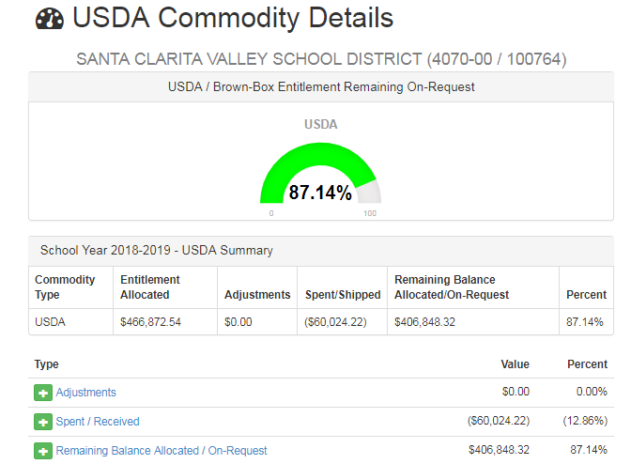
USDA Live Inventory Report – This report provides a list of all Direct Delivery items currently in Member District inventory at Gold Star Foods. Access on the Gold Star Foods website at http://www.goldstarfoods.com/. Click on Order Online and enter your Username and Password. Under the Reports tab on the left, click on USDA Live Inventory.
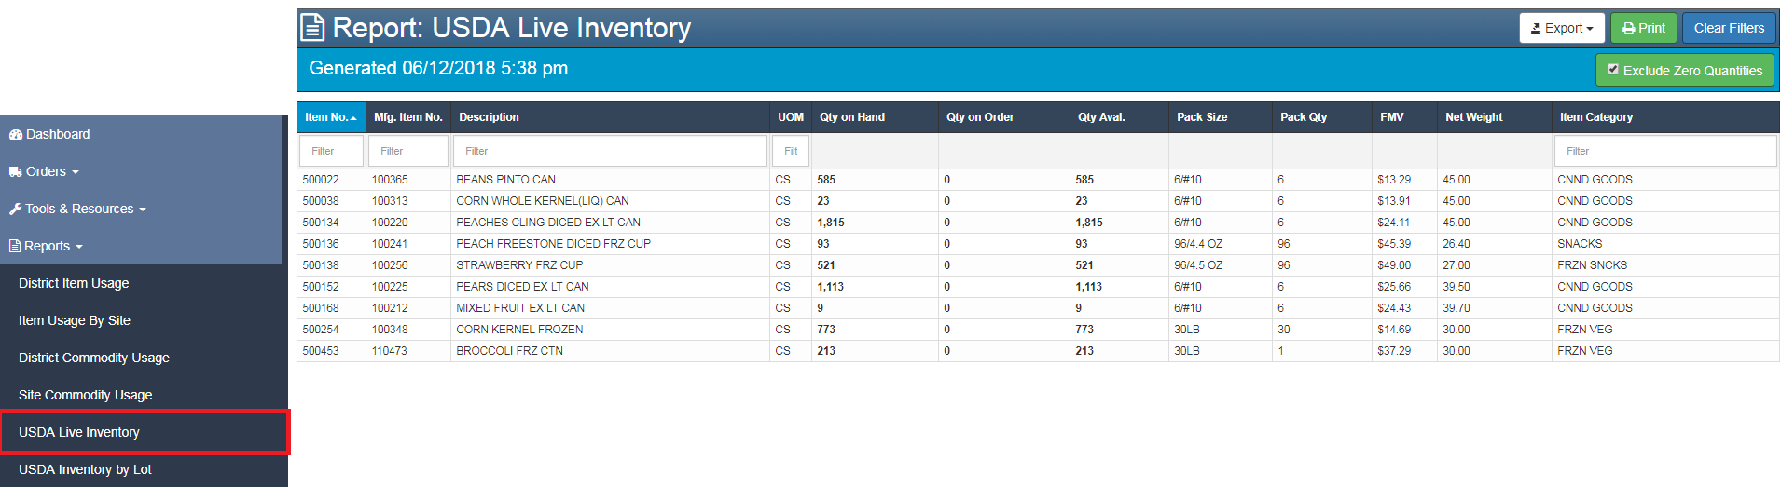
USDA Inventory by Lot Report – This report provides a list of all items currently in Member Districts’ inventory denoting the date of receipt and the date that Members will begin paying storage charges. Access on the Gold Star Foods website at http://www.goldstarfoods.com/. Click on Order Online and enter your Username and Password. Under the Reports tab on the left, click on USDA Inventory by Lot.
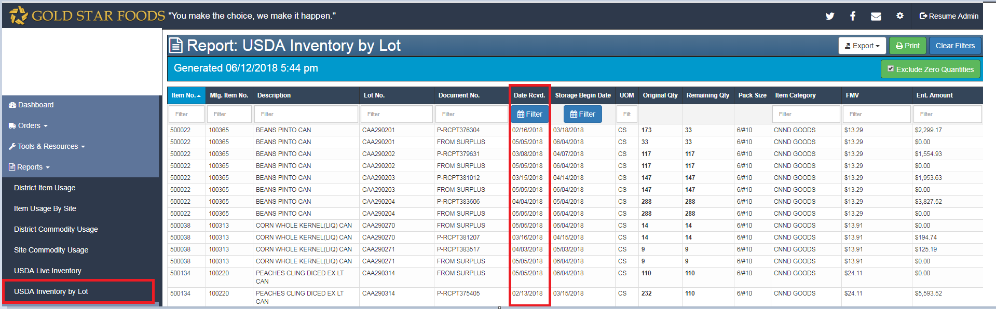
USDA Foods Processing
The Super Co-Op diverts USDA Foods to processors in truckload quantities and those products are available for any Member District to utilize within their entitlement balance.
Requesting Processed USDA Foods
Once you have determined which USDA Foods processed items you want to use on your menus, be sure you have the manufacturer’s code item for the commodity product. Many manufacturers make the same items not using USDA Foods, so to get the proper USDA Foods credit, be sure you are ordering the correct product from the distributor. When you place an order with a distributor, check the Super Co-Op website to be sure you have remaining entitlement dollars to spend before your order is placed with the manufacturer.
Processors
Approved USDA Foods processors must be used by RAs. The Super Co-Op publishes an RFP each year for processors to provide pricing and Summary End Product Data Schedule (SEPDS) documentation to Member Districts. The Super Co-Op assures that processors have approved SEPDS documentation for each of the items offered on the RFP. The approved items, prices, and processors are posted on the Super Co-Op website. RAs must purchase food items approved through the RFP process in order to receive entitlement credit (discount) for processed food items. USDA Foods balances at processors can be viewed on your Super Co-Op web page Dashboard.
Direct Shipment
Some processors will ship minimum quantities of processed USDA Foods directly to your designated delivery location. Inquire with your processor and/or broker about this process.
Distributors
Each Member District is responsible to contract with a Super Co-Op and State-approved distributor to deliver processed USDA Foods to their local district. Distributors must have an agreement with approved Processors, the State Agency, and the Super Co-Op in order to be used by the Member District. A list of approved USDA Foods distributors is posted on the Super Co-Op website.
Receiving materials and supplies through a distributor requires RAs to follow the proper federal, state, and local procurement procedures. Effective January 1, 2018, Senate Bill 544, Contracting for Purchases for the Child Nutrition Programs (Chapter 395, Statutes of 2017) amends the California Public Contract Code, Section 20111. The result of this amendment is that public school districts (PSD) and county offices of education (COE) are permitted to follow the federal small purchase threshold, unless your local small purchase threshold is more restrictive. Effective August 1, 2018, the federal micropurchase threshold increased to $10,000, and the federal small purchase threshold increased to $250,000. Additionally, PSDs and COEs can award competitive proposal procurements (Title 2, Code of Federal Regulations, Section 200.320[d]) to the most responsive and responsible party, where price is the primary consideration, but not the only determining factor As always, program operators are required to use the most restrictive threshold for the procurement method being used. Additional information can be found on the CDE website at https://www.cde.ca.gov/ls/nu/sn/fsmcproc.asp
Product Formulation Statements (PFS)
A Product Formulation Statement (PFS) is used to validate how a food product contributes toward meal pattern requirements. If a product does not have an approved Child Nutrition (CN) label or is not found in the Food Buying Guide, the manufacturer must provide a PFS. It is the RAs responsibility to ensure that all foods served meet meal pattern requirements.
Summary End Product Data Schedules (SEPDS)
The Summary End Product Data Schedule (SEPDS) form is a listing of all products from a processor with information that is critical to effectively use USDA Foods. The SEPDS includes:
USDA Food item and material code(s), weight, number of servings, pounds of USDA Foods used per finished case. This information will help you calculate how much USDA Foods you will use per case of finished processed product and be able to validate that you received the full value of the USDA Foods contained in each case of end product processed USDA Foods. SEPDS for all items on the Super Co-Op RFP are available on the Super Co-Op website. This is a sample form:
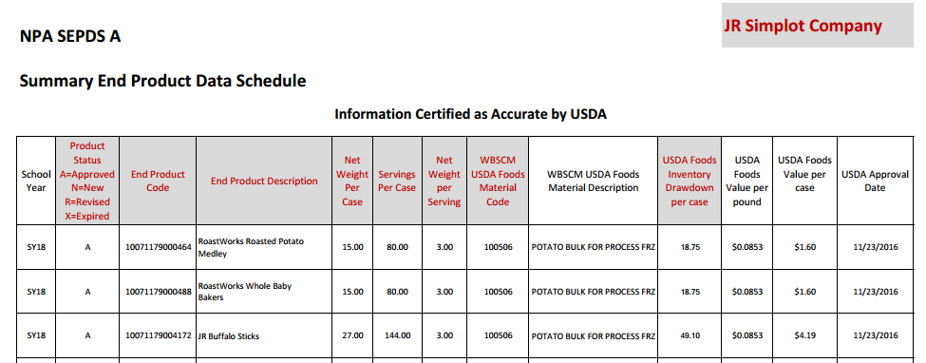

Verification of VPT
It is important that Member Districts verify each processed commodity purchase and delivery. Each time a processed commodity is received, you should check to be sure the proper discount (NOI, FFS, or rebate) was issued and that entitlement was drawn down correctly.
Department of Defense (DoD) Fresh Produce
Member Districts can set aside a portion of their annual entitlement to use for fresh and value added produce via the DoD Produce ordering process. When you set aside a portion of your entitlement to DoD Produce you will be assigned access to the FFAVORS Web, the web-based Fresh Fruit and Vegetable Order/Receipt System (FFAVORS). Currently, Valley Produce is the approved DoD vendor in Southern California and Rohrer Brothers is the approved DoD vendor in Northern California. Member districts will either receive DoD produce directly from the DoD vendor or have their DoD produce sent to another distributor. When member districts sign up for DoD, the specific details will be finalized.
Unprocessed Fruit & Vegetable Pilot Program
Section 4202 of the Agricultural Act of 2014 (P.L. 113-79), otherwise known as the Farm Bill, amended Section 6 of the Richard B. Russell National School Lunch Act (42 U.S.C. 1755(f)) to provide for a pilot project for the procurement of unprocessed fruits and vegetables in not more than eight States receiving funds under Section 6. USDA's Food and Nutrition Service (FNS) works closely with USDA's Agricultural Marketing Service (AMS) to implement this pilot project, which began in early 2015. Participating states include California, Connecticut, Michigan, New York, Oregon, Virginia, Washington, and Wisconsin. Several member districts of the SUPER Co-Op are participating in this pilot for SY 2018-19.
The pilot project will provide State Distributing Agencies (SDAs) in selected States additional flexibility in the procurement of unprocessed fruits and vegetables. School food authorities (SFAs) in selected States, or SDAs acting on behalf of participating SFAs, will be permitted to competitively solicit a USDA-approved vendor using USDA Foods National School Lunch Program (NSLP) entitlement funds. SDAs or SFAs will also be able to use pre-existing commercial distribution channels and relationships with growers, produce wholesalers, and distributors. Use of geographic preference, as allowed by FNS regulation, is permitted in the procurement of these products.
Complaints
If you have a complaint about a USDA Foods product, please contact Cynthia Barcelo at the Super Co-Op office. A formal report will be made through the CDE to USDA.
E-mail- CynthiaBarcelo@Super-Coop.org Phone- (909) 843-9640
Proper Storage of USDA Foods
Per Title 7, Code of Federal Regulations (CFR), Section 250.1(c)(1), USDA Foods Direct Delivery (aka “brown box”) inventory may not exceed an amount needed for a six-month period. Member Districts should request Direct Delivery items accordingly. Correct temperature control is essential to maintain food quality, nutrient content, and control of bacterial growth. Daily monitoring of temperatures is necessary to ensure adequate storage conditions.
Dry Storage: Many items such as canned goods, baking supplies, grains, and cereals may be held safely in dry storage areas. The guidelines below should be followed:
Keep dry storage areas clean with good ventilation to control humidity and prevent the growth of mold and bacteria.
Store dry foods at 50°F for maximum shelf life. However, 70°F is adequate for dry storage of most products.
Place a thermometer on the wall in the dry storage area.
Check the temperature of the storeroom daily.
Store foods away from sources of heat and light, which decrease shelf life.
Store foods off the floor and away from walls to allow for adequate air circulation.
Refrigerated Storage: Refrigeration increases shelf life of most products. Most importantly, refrigeration slows bacterial growth. Optimal refrigerated storage conditions can be achieved by following these guidelines:
Maintain refrigerated storage spaces at 32-40°F
Make thermometers readily observable, easily readable, and accurate to +3°F.
Position the temperature sensor to register the warmest air in the refrigerated space to ensure adequate cooling.
Establish the correct refrigerator temperature by placing a thermometer in a glass of water in the middle of the refrigerator. Wait 5 to 8 hours. If the temperature is not 38-40°F, adjust the temperature control. Check again after 5-8 hours.
Ensure that refrigerators have enough open, slotted shelving to allow for air circulation around shelves and refrigerator walls to maintain proper food temperatures.
Ensure that doors have a good seal and close tightly to maintain the temperature and the efficiency of the unit. Additionally, keep doors closed as much as possible.
Keep a back-up appliance thermometer in the unit in case of a power outage. If the refrigerator is still 40°F when the power returns, the food is safe. The food should not be consumed if the temperature is held at 40°F for more than two hours.
Freezer Storage: Freezers should be used to store frozen food when it is received. Optimal frozen storage conditions can be achieved by following these guidelines:
Maintain freezer storage spaces at 0°F or below.
Make thermometers readily observable, easily readable, and accurate to +3°F.
Position the temperature sensor to represent the actual storage temperature or place several thermometers in the unit to ensure accuracy and consistency.
Establish the correct temperature in the freezer by placing a thermometer between frozen food packages. Wait 5 to 8 hours. If the temperature is not 0-2°F, adjust the freezer temperature control. Check again after 5-8 hours.
Ensure that freezers have enough open, slotted shelving to allow for air circulation around shelves and walls to maintain adequate food temperatures.
Ensure that doors have a good seal and close tightly to prevent heat gain. Additionally, keep doors closed as much as possible.
Keep a back-up appliance thermometer in the unit in case of a power outage. If the freezer is still 0°F when the power returns, the food is safe.
Reference: Nutrition Services Division Management Bulletin No. 00-404, March 2000. Retrieved from http://www.cde.ca.gov/ls/nu/fd/mb00404.asp
Super Co-Op Governance
The Super Co-Op is governed by a ten member committee (Governing Council); each member represents members from each of nine Regional Groups and one representative from the Lead District. The Governing Council meets several times a year and makes decisions about the operation of the Co-Op. There are Governing Rules that are used to govern the Co-op business, found at the end of this document.
Regional Group | Director / Contact | District
Lead District | Andrew Soliz | San Mateo-Foster City School District
 | (650) 312-1968 | asoliz@smfc.k12.ca.us
Region 2 | Amy Hedrick-Farr | Santa Cruz City School District
 | (831) 429-3850 | ahedrick-farr@sccs.net
Region 3 | Alissa Angle | Central Unified School District
 | (559) 274-4700 ext. 63108 | aangle@centralusd.k12.ca.us
Region 4 | Stephanie Gillenberg | Oxnard Union High School District
 | (805) 385-5749 | Stephanie.Gillenberg@ouhsd.k12.ca.us
Region 5 | Léna Agee | Manhattan Beach USD
 | (310) 318-7345 x5031 | LAgee@manhattan.k12.ca.us
Region 6 | Michelle Curry | South Pasadena USD
 | (626) 441-5820 x 2950 | mcurry@spusd.net
Region 7 | Liz Brown-Smith | Whittier Union High SD
 | (562) 698-8121 x 1092 | Liz.Brown-Smith@wuhsd.org
Region 8 | Daryl Hickey | Pomona USD
 | (909) 397-4711 x 21100 | Daryl.Hickey@pomona.k12.ca.us
Region 9 | Stephanie Bruce | Palm Springs USD
 | (760) 322-4117 | sbruce@psusd.us

Lead District
The San Mateo-Foster City School District is the Lead District for the Super Co-Op for the 2019-20 School Year. The Lead District works with the Governing Council to promote the best interest of the Member Districts as a group. The Lead District requests all USDA Foods on behalf of the Member Districts and makes processing diversion decisions with the Governing Council.
The Lead District is responsible for issuing, evaluating, and approving all bid documents related to the Co-Op’s business. All accepted proposals and/or bids are approved by the Lead District’s Board of Education. In addition, the Lead District oversees the Administrator contract and performance, manages Co-Op funds, and pays state administrative fees relative to USDA Foods received by the Member Districts.
Lead District Contact Information
San Mateo-Foster City School District
Andrew Soliz
(650) 312-1968 asoliz@smfc.k12.ca.us
Administrator
Gold Star Foods is the Administrator for the Super Co-Op for the 2018-19 School Year. The Administrator performs many functions including:
- Calculating Member District’s USDA Foods entitlement,
- Coordinating the USDA Foods annual survey,
- Notifying Member Districts of USDA Foods offering(s), coordinating data collection/orders, re-capping the orders,
- Tracking incoming USDA Foods, comparing them against the original orders and informing the Member Districts about any discrepancies,
- Tracking deliveries of USDA Foods from approved distributors to Member Districts,
- Maintaining the Super Co-Op website to inform Member Districts of the actual remaining balances in FMV dollars, available balances at processors, bids, SEPDS
- Collecting, monitoring and validating all available balances of bulk USDA Foods stored with processors,
- Collecting state administrative fee payments from Member Districts,
- Checking state invoices to actual deliveries and investigating and clearing any discrepancies prior to payment of the invoices,
- Providing a summary of all charges to each Member District on a monthly basis,
- Making and verifying USDA Foods balance transfers,
- Coordinating annual Food Shows, north and south state.

The Administrator can be reached using the following contact information:
Administrator Contact Information
Cynthia Barcelo
E-mail- CynthiaBarcelo@Super-Coop.org
Phone- (909) 843-9640 Fax- (909) 843-9641
Hours of Operation: Mon-Fri 8:00AM-4:00PM

Administrative Website
Your Member Dashboard on the Super Co-Op website is a critical tool for use in monitoring your USDA Foods entitlement balances. Please take time to view the “SCOOP Tutorial Video” on the Super Co-Op website homepage to best use the tools available to you on the website. You will need to get log-on credentials from the Administrator to view your Member District information.
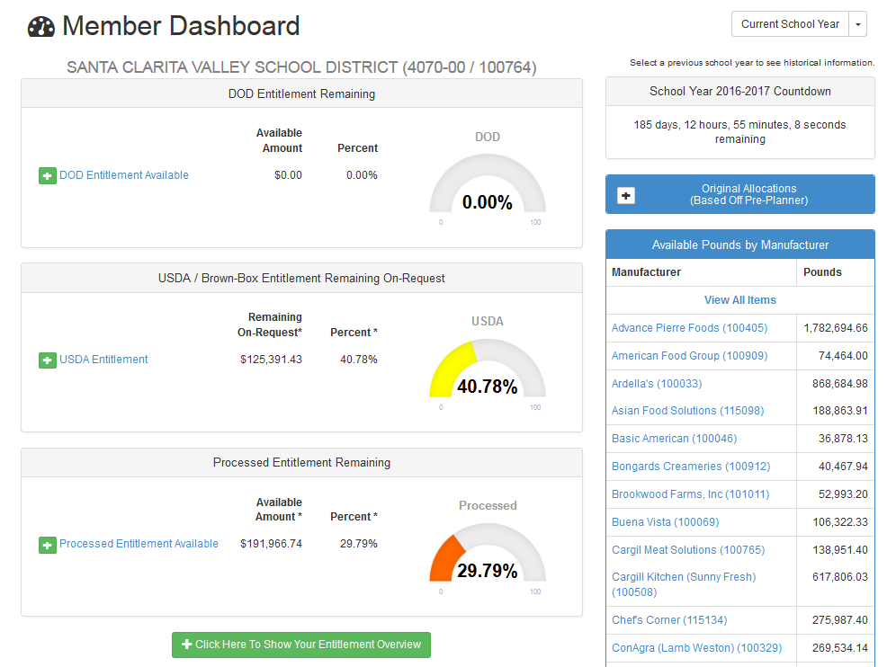

How to get started
Super Co-Op Member Districts must be eligible to receive USDA Foods and be located in the state of California. When joining the Super Co-Op, each district signs an “Agreement of USDA Foods” which diverts the USDA Foods entitlement from the Member District to the Lead District. This may require Member District board action.
Fee Structure
Member Districts are billed by the Lead District for annual membership fee; the Administrator bills the state administrative fees. See Super Commodity Cooperative Fee Structure on page 17.
Responsibilities of the Member District
- Pay your bills promptly.
- Respond to pre-planners and offerings promptly.
- Read all emails and correspondence from the Super Co-Op and respond promptly.
- Use your USDA Foods wisely, using all your entitlement in a timely fashion.
- Verify your VPT using the Super Co-Op RFP Recap found on the Super Co-Op website. If discrepancies are found, address them with your processed commodity distributor directly.
- Monitor your entitlement balance using the Super Co-Op website to be sure that your processed product is reported by distributors and processors, so your entitlement draw down is reflected correctly.
To determine what USDA Foods and what forms are the best value to your district, please refer to Page 13 of the ACDA – RA Manual “Analyzing Costs and Value” found on the Super Co-Op website.
SY2019-20 Super Co-Op Regional Groups
REGION 1 | REGION 2 - CONTINUED | REGION 3 - CONTINUED
BRITTAN SCHOOL DISTRICT | SALINAS CITY ELEMENTARY SCHOOL DISTRICT | KINGS RIVER HARDWICK SCHOOL DISTRICT
BUCKEYE UNION SCHOOL DISTRICT | SAN BENITO HIGH SCHOOL DISTRICT | KINGSBURG JOINT UNION SD
CORNING UNION ELEMENTARY SCHOOL DIST | SAN LORENZO UNIFIED SCHOOL DISTRICT | LATON JOINT UNIFIED SCHOOL DISTRICT
EAST NICOLAUS JOINT UNION HSD | SAN MATEO-FOSTER CITY SCHOOL DISTRICT | LEMOORE UNION ELEMENTARY SCH DIST
HAMILTON UNIFIED SCHOOL DISTRICT | SAN RAFAEL CITY ELEMENTARY SCHOOL DIST | LEMOORE UNION HIGH SCHOOL DISTRICT
LODI UNIFIED SCHOOL DISTRICT | SANTA CRUZ CITY ELEM SCHOOL DISTRICT | LINDSAY UNIFIED SCHOOL DISTRICT
MARCUM-ILLINOIS UNION SCHOOL DISTRICT | Santa Rita Union School District | LOS BANOS UNIFIED SCHOOL DISTRICT
NATOMAS UNIFIED SCHOOL DISTRICT | SONOMA VALLEY UNIFIED SCHOOL DISTRICT | MADERA UNIFIED SCHOOL DISTRICT
OROVILLE UNION HIGH SCHOOL DISTRICT | SOUTH SAN FRANCISCO SCHOOL DISTRICT | MARIPOSA SCHOOL DISTRICT
PARADISE UNIFIED SCHOOL DISTRICT | REGION 3 | MC SWAIN ELEMENTARY SCHOOL DISTRICT
PLUMAS LAKE ELEMENTARY SCHOOL DIST | ALVIEW DAIRYLAND UNION SCHOOL DISTRICT | MENDOTA UNIFIED SCHOOL DISTRICT
RED BLUFF ELEMENTARY SCHOOL DISTRICT | ARMONA UNION ELEMENTARY SCHOOL DIST | Modesto City Elementary School District
RESCUE UNION SCHOOL DISTRICT | ATWATER UNIFIED SCHOOL DISTRICT | MONSON-SULTANA JOINT UNION ELEMENTARY
ROSEVILLE JOINT UNION HIGH S D | Caruthers Unified School District | PARLIER UNIFIED SCHOOL DISTRICT
SAN JUAN UNIFIED SCHOOL DISTRICT | CENTRAL UNIFIED SCHOOL | PIONEER UNION ELEMENTARY
THERMALITO UNION SCHOOL DISTRICT | CENTRAL UNION SCHOOL DISTRICT | PIXLEY UNION SCHOOL DISTRICT
WASHINGTON UNIFIED SCHOOL DISTRICT | CERES UNIFIED SCHOOL DIST | PORTERVILLE UNIFIED SCHOOL DISTRICT
REGION 2 | CHOWCHILLA ELEM SCHOOL DISTRICT | REEF-SUNSET UNIFIED SCHOOL DISTRICT
ACALANES UNION HIGH SCHOOL DISTRICT | CHOWCHILLA UNION SCHOOL DISTRICT | RIVERDALE JOINT UNIFIED SCHOOL DISTRICT
ALAMEDA UNIFIED SCHOOL DISTRICT | CLOVIS UNIFIED SCHOOL DISTRICT | SANGER UNIFIED SCHOOL DISTRICT
ANTIOCH UNIFIED SCHOOL DISTRICT | COALINGA-HURON UNIFIED SCHOOL DISTRICT | SELMA UNIFIED SCHOOL DISTRICT
AROMAS SAN JUAN UNIFIED SCHOOL DISTRICT | CORCORAN UNIFIED SCHOOL DISTRICT | SIERRA UNIFIED SCHOOL DISTRICT
BRENTWOOD UNION SCHOOL DISTRICT | CUTLER-OROSI SCHOOL DISTRICT | TIPTON ELEMENTARY SCHOOL DISTRICT
Campbell Union High School District | DINUBA UNIFIED SCHOOL DISTRICT | TULARE CITY SCHOOL DISTRICT
CASTRO VALLEY UNIFIED SCHOOL DISTRICT | EXETER UNIFIED SCHOOL DISTRICT | TULARE JOINT UNIFIED SCHOOL DISTRICT
COUNTY OF SANTA CLARA | FOWLER UNIFIED SCHOOL DISTRICT | VISALIA UNIFIED SCHOOL DISTRICT
CUPERTINO UNION SCHOOL DISTRICT | GOLDEN PLAINS UNIFIED | WEAVER UNION ELEMENTARY SCHOOL DISTRICT
FREMONT UNIFIED SCHOOL DISTRICT | GOLDEN VALLEY UNIFIED SCHOOL DISTRICT | WEST PARK ELEMENTARY SCHOOL DISTRICT
HOLLISTER SCHOOL DISTRICT | Gustine Unified School District | WOODLAKE PUBLIC SCHOOLS
LIVE OAK ELEMENTRY SD | HANFORD ELEMENTARY SCHOOL DISTRICT | Woodville Union Elementary School District
MONTEREY PENINSULA UNIFIED SCHOOL DIST | HANFORD JOINT UNION HIGH SCHOOL DIST
MORGAN HILL UNIFIED SCHOOL DISTRICT | KERMAN UNIFIED SCHOOL DISTRICT
NORTH COUNTY JOINT UNIFIED SCHOOL DIST | KERN HIGH SCHOOL DISTRICT
NOVATO UNIFIED SCHOOL DISTRICT | KING CITY UNION SCHOOLS
PAJARO VALLEY UNIFIED SCHOOL DISTRICT | KINGS CANYON UNIFIED SCHOOL DISTRICT

SY2019-20 Super Co-Op Regional Groups - continued

REGION 4 | REGION 6 - CONTINUED | REGION 8
COAST UNIFIED SCHOOL DISTRICT | Glendale Unified School District | ADELANTO ELEMENTARY SCHOOL DISTRICT
GRANADA HILLS CHARTER SCHOOL | GLENDORA UNIFIED SCHOOL DISTRICT | ALTA LOMA SCHOOL DISTRICT
HUENEME ELEMENTARY SCHOOL DISTRICT | HACIENDA-LA PUENTE UNIFIED SCHOOL DISTRICT | ALVORD UNIFIED SCHOOL DISTRICT
LAS VIRGENES UNIFIED SCHOOL DISTRICT | MONROVIA UNIFIED SCHOOL DISTRICT | BONITA UNIFIED SCHOOL DISTRICT
LOMPOC UNIFIED SCHOOL DISTRICT | MOUNTAIN VIEW ELEMENTARY SCHOOL DIST | Central Elementary School District
MOORPARK SCHOOL DISTRICT | PASADENA UNIFIED SCHOOL DISTRICT | CHAFFEY JOINT HIGH SCHOOL DISTRICT
OAK PARK UNIFIED SCHOOL DISTRICT | ROSEMEAD SCHOOL DISTRICT | CHINO VALLEY UNIFIED SCHOOL DISTRICT
OJAI UNIFIED SCHOOL DISTRICT | ROWLAND UNIFIED SCHOOL DISTRICT | CLAREMONT UNIFIED SCHOOL DISTRICT
ORCUTT UNIFIED SCHOOL DISTRICT | SAN GABRIEL SCHOOL DISTRICT | COLTON JOINT UNIFIED SCHOOL DISTRICT
OXNARD ELEMENTARY SCHOOL DISTRICT | SAN MARINO UNIFIED SCHOOL DISTRICT | CORONA NORCO UNIFIED SCHOOL DISTRICT
OXNARD UNION HIGH SCHOOL DISTRICT | SOUTH PASADENA UNIFIED SCHOOL DISTRICT | CUCAMONGA ELEMENTARY SCHOOL DISTRICT
PASO ROBLES JOINT UNIFIED HIGH SCHOOL DIST | TEMPLE CITY UNIFIED SCHOOL DISTRICT | FONTANA UNIFIED SCHOOL DISTRICT
SAN LUIS COASTAL UNIFIED SCHOOL DISTRICT | WEST COVINA UNIFIED SCHOOL DISTRICT | JURUPA UNIFIED SCHOOL DISTRICT
SANTA CLARITA VALLEY SCHOOL DISTRICT | REGION 7 | MORENO VALLEY UNIFIED SCHOOL DISTRICT
SANTA MARIA BONITA ELEMENTARY | ABC UNIFIED SCHOOL DISTRICT | MOUNTAIN VIEW SCHOOL DISTRICT
SIMI VALLEY UNIFIED SCHOOL DISTRICT | ANAHEIM UNION HIGH SCHOOL DISTRICT | POMONA UNIFIED SCHOOL DISTRICT
VAUGHN NEXT CENTURY CENTER | BREA OLINDA UNIFIED SCHOOL DISTRICT | RIALTO UNIFIED SCHOOL DISTRICT
VENTURA UNIFIED SCHOOL DISTRICT | BUENA PARK UNIFIED SCHOOL DISTRICT | RIVERSIDE UNIFIED SCHOOL DISTRICT
REGION 5 | CYPRESS UNIFIED SCHOOL DISTRICT | SAN BERNARDINO CITY UNIFIED SCHOOL DIST
BELLFLOWER UNIFIED SCHOOL DISTRICT | DOWNEY UNIFIED SCHOOL DISTRICT | UPLAND UNIFIED SCHOOL DISTRICT
COMPTON UNIFIED SCHOOL DISTRICT | EAST WHITTIER CITY SCHOOL DISTRICT | VAL VERDE UNIFIED SCHOOL DISTRICT
CULVER CITY UNIFIED SCHOOL DISTRICT | EL RANCHO UNIFIED SCHOOL DISTRICT | REGION 9
EL SEGUNDO UNIFIED SCHOOL DISTRICT | FULLERTON SCHOOL DISTRICT | BANNING UNIFIED SCHOOL DISTRICT
HAWTHORNE SCHOOL DISTRICT | HUNTINGTON BEACH UNION HIGH SCHOOL DIST | BARSTOW UNIFIED SCHOOL DISTRICT
Inglewood Unified School District | IRVINE UNIFIED SCHOOL DISTRICT | BEAR VALLEY UNIFIED SCHOOL
Lawndale Elementary School District | LA HABRA CITY SCHOOL DISTRICT | BEAUMONT UNIFIED SCHOOL DISTRICT
Lennox School District | LITTLE LAKE CITY SCHOOL DISTRICT | COACHELLA VALLEY UNIFIED SCHOOL DISTRICT
LYNWOOD UNIFIED SCHOOL DISTRICT | LOS ALAMITOS UNIFIED SCHOOL DISTRICT | CORONADO UNIFIED SCHOOL DISTRICT
MANHATTAN BEACH UNIFIED SCHOOL DISTRICT | LOWELL JOINT SCHOOL DISTRICT | DESERT SANDS UNIFIED SCHOOL DISTRICT
PALOS VERDES UNIFIED SCHOOL DISTRICT | MAGNOLIA SCHOOL DISTRICT | ESCONDIDO UNION HIGH SCHOOL DISTRICT
REDONDO BEACH UNIFIED SCHOOL DISTRICT | NEWPORT MESA UNIFIED SCHOOL DISTRICT | HESPERIA SCHOOL DISTRICT
SANTA MONICA-MALIBU UNIFIED SCHOOL DIST | NORWALK LA MIRADA UNIFIED SCHOOL DIST | Inland Leaders Charter School
TORRANCE UNIFIED SCHOOL DISTRICT | OCEAN VIEW SCHOOL DISTRICT | LAKE ELSINORE UNIFIED SCHOOL DISTRICT
REGION 6 | ORANGE COUNTY DEPARTMENT OF EDUCATION | LEMON GROVE UNIFIED SCHOOL DISTRICT
ALHAMBRA SCHOOL DISTRICT | ORANGE UNIFIED SCHOOL DISTRICT | MENIFEE UNION SCHOOL DISTRICT
ARCADIA UNIFIED SCHOOL DISTRICT | PLACENTIA YORBA LINDA SCHOOL DISTRICT | MORONGO UNIFIED SCHOOL DISTRICT
AZUSA UNIFIED SCHOOL DISTRICT | SADDLEBACK VALLEY UNIFIED SCHOOL DISTRICT | MURRIETA VALLEY USD
BALDWIN PARK UNIFIED SCHOOL DISTRICT | SANTA ANA UNIFIED SCHOOL DISTRICT | NATIONAL SCHOOL DISTRICT
BASSETT UNIFIED SCHOOL DISTRICT | SOUTH WHITTIER SCHOOL DISTRICT | ORO GRANDE SCHOOL DISTRICT
BURBANK UNIFIED SCHOOL DISTRICT | TUSTIN UNIFIED SCHOOL DISTRICT | PALM SPRINGS UNIFIED SCHOOL DISTRICT
CHARTER OAK UNIFIED SCHOOL DISTRICT | WALNUT VALLEY UNIFIED SCHOOL DISTRICT | PALO VERDE UNIFIED SCHOOL DISTRICT
COVINA VALLEY SCHOOL DISTRICT | WESTMINSTER SCHOOL DISTRICT | PERRIS ELEMENTARY SCHOOL DISTRICT
DUARTE UNIFIED SCHOOL DISTRICT | WHITTIER CITY SCHOOL DISTRICT | PERRIS UNION HIGH SCHOOL DISTRICT
EL MONTE CITY ELEMENTARY SCHOOL DISTRICT | WHITTIER UNION HIGH SCHOOL DISTRICT | Redlands Unified School District
EL MONTE UNION HIGH SCHOOL DISTRICT |  | ROMOLAND SCHOOL DISTRICT
GARVEY ELEM SCHOOL DISTRICT |  | SOUTH BAY UNION SCHOOL DISTRICT
 |  | SWEETWATER UNION HIGH SCHOOL DISTRICT
 |  | TEMECULA VALLEY UNIFIED SCHOOL DISTRICT
REGIONAL GROUP LEAD |  | VICTOR VALLEY UNION HIGH SCHOOL DISTRICT
CO-OP LEAD DISTRICT |  | VISTA UNIFIED SCHOOL DISTRICT
 |  | YUCAIPA-CALIMESA JOINT UNIFIED SCHOOL DIST

Annual Timeline

July
Complete the Agreement for Distribution of Donated Food in CNIPs.
Membership Fee invoices distributed.
October - November
Annual Renewal of Services forms distributed and due to Co-Op Administrator for next school year.
December
December 15th is the last day to opt in or out of co-op or state distribution for next school year.
January – February
Super Co-Op Food Shows, north and south
Visit a food show to assist in making decisions about USDA Foods processing for following year
Current year entitlement is redistributed if Member District remaining entitlement balance is too high (January 31)

February – March
Request USDA Foods (chicken pounds by manufacturer, brown box, DoD, and Unprocessed Pilot entitlement amount) for following year
Current year entitlement is redistributed if Member District remaining entitlement balance is too high (March 30)

May
DoD Fresh produce funds swept by CDE if not used.

June
All unused entitlement funds expire on June 30.

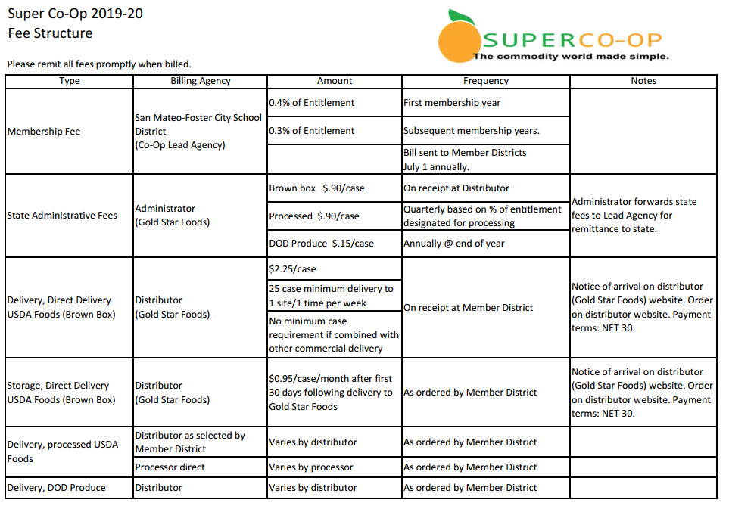
USDA Foods Direct Delivery (Brown Box) Storage Policy
Approved by the Governing Council - July 1, 2018

Per Title 7, Code of Federal Regulations (CFR), Section 250.1(c)(1), USDA Foods Direct Delivery (aka “Brown Box”) inventory may not exceed an amount needed for a six-month period. To assist Member Districts in the management of direct delivery inventory, the following policies apply to Direct Delivery USDA Foods received and stored at the Super Co-Op USDA Foods Direct Delivery Distributor (Gold Star Foods):
Direct Delivery Items with a Six Month Shelf-Life
- It is the responsibility of the Member District to schedule delivery of product as soon as possible after receipt at the Super Co-Op USDA Foods Direct Delivery Distributor (Gold Star Foods).
- At 120 days (4 months), if the item has not been scheduled by the member district for delivery, inventory is moved into the Super Co-op General Account and offered to any Member District willing to take delivery of product in 30 days or less. The originating district pays state administrative fee and their entitlement is charged. The receiving district gets the product at no charge to their entitlement and pays delivery charges.
- At 150 days (5 months), if the item has not been scheduled by the member district for delivery, the inventory is donated to a local non-profit agency (Ex: foodbank). The originating district’s entitlement is charged for the item and they pay the state administrative fee.
- Six Month Shelf Life Items:
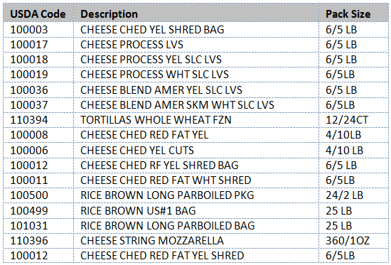
All Other Direct Delivery Items
- It is the responsibility of the Member District to schedule delivery of product as soon as possible after receipt at the Super Co-Op USDA Foods Direct Delivery Distributor (Gold Star Foods).
- At 10 months, if the item has not been scheduled by the member district for delivery, the inventory is moved to the Super Co-Op General Account and offered to any Member District willing to take delivery of the product within 30 days or less. The originating district pays state administrative fee and their entitlement is charged. The receiving district gets the product at no charge to their entitlement and pays delivery charges.
- Depending on the product expiration date, the inventory may be donated to a local non-profit agency (Ex: foodbank) just prior to expiration.

Direct Delivery Management Reports
Direct Delivery Allocations – This report provides a list of all items allocated to Member Districts that have not yet been received at Gold Star Foods. Member Districts should use this report to plan future menus utilizing direct delivery USDA Foods. Access on your Super Co-Op Dashboard at http://www.super-coop.org/. Click on Log-In and enter your Username and Password.
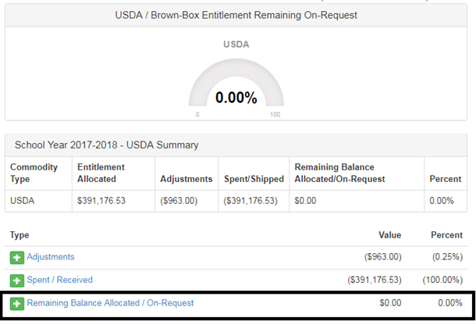

USDA Live Inventory Report – This report provides a list of all Direct Delivery items currently in Member District’s inventory at Gold Star Foods. Access on the Gold Star Foods website at http://www.goldstarfoods.com/. Click on Order Online and enter your Username and Password. Under the Reports tab on the left, click on USDA Live Inventory.
USDA Inventory by Lot Report – This report provides a list of all items currently in Member District’s inventory denoting the date of receipt and the date that Members will begin paying storage charges. Access on the Gold Star Foods website at http://www.goldstarfoods.com/. Click on Order Online and enter your Username and Password. Under the Reports tab on the left, click on USDA Inventory by Lot.

SUPER Co-Op Governing Rules
- PURPOSE
The purpose of the SUPER Co-Op is to assist Member Districts with effective USDA Foods ordering and distribution and enable its members to attain the best possible prices for processed USDA Foods and their commercial equivalents as well as for USDA Foods distribution (brown boxes).

- MEMBERSHIP
  - All Member Districts must abide by the Governing Rules as presented.
  - Any California agency that is eligible to receive the USDA Foods may apply to become a member of the Co-Op.
    - The Super Co-Op Governing Council (Council) has the right to approve or disapprove of the membership’s status of a co-op member.
    - If a USDA Foods distribution contract is in force and a new member is applying during this contract existence, its membership may require the contracted distributor’s approval.
  - By signing the “Assignment of USDA Donated Food” (Appendix 1) the Agency agrees to be a member of the SUPER Co-Op and to abide by the SUPER Co-Op Governing Rules.
  - Every Member District is entitled to its “Fair Share” of all offered USDA Foods based on the previous year Total Lunches Served (TLS) and current minimum value of donated foods per lunch served as assigned by the State.
  - Member Districts can resign membership at the end of any program year with written notice received by the Lead Agency by December 10 of the preceding program year.
    - All USDA Foods Direct Delivery (brown box) product left in storage on June 30 shall be forfeited and offered to remaining Member Districts unless prior arrangements are made by June 1.
    - All unspent entitlement and processor balances on June 30 shall be forfeited.
  - It is the Member District’s responsibility to inform its board of trustees about SUPER Co-Op business, including the status of any USDA Foods related bids and proposals.
  - It is every Member District’s responsibility to actively manage its USDA Foods including distribution, processing, and inventories. Each Member District must maintain internet and e-mail access and is responsible to report changes to the Lead Agency and Administrator. Each Member District must use the Co-Op approved method of ordering commodities.
  - Each Member District must pay invoices from the Co-Op or an approved Co-Op agent within 30 days of the receipt of invoice.
    - A penalty of 5% may be assessed after 90 days if the invoice is not paid in full. An additional 2% can be assessed after 120 days.
    - Repeated late payments may result in cancellation of membership in the Co-Op.
  - Each Co-Op Member District is responsible to monitor their entitlement balance and other reports and announcements on the Co-Op web site.
III. GOVERNANCE
  - All of the SUPER Co-Op business and organizational decisions shall be made by the SUPER Co-Op Governing Council (Council). The Council shall be comprised of one member per regional group plus a Lead Agency representative.
    - Regional Group membership will be approved by the Council.
    - Council members will be determined by members of each Regional Group.
    - Each Council member is entitled to one vote on each matter submitted for a vote of the members. A Council member may give another individual in its Regional Group its proxy for voting purposes if they are unavailable to vote.
    - The Lead Agency representative will only cast a vote in the event of a tie.
  - The Council shall meet a minimum of once a year or as needed. The Council’s decisions shall be reached by a majority of present Council members if a quorum is met.
    - A Council quorum is met if 51% or more Council members are present.
    - Council members and Lead Agency shall be reimbursed for expenses incurred to attend Council meetings from the membership fee account.
  - A Member District will act as the Lead Agency for the SUPER Co-Op.
    - The Lead Agency is responsible for requesting all USDA Foods Direct Delivery and diversions to processors as well as for all the USDA Food inventories at the processors’ storage facilities.
      - As soon as a USDA Foods shipment is delivered to an approved distributor and is assigned to an eligible member, the USDA Food is inventoried as commercial product of the eligible member (single inventory). It is each Co-Op Member District’s responsibility to manage its inventory to achieve maximum benefit.
    - The Lead Agency is responsible for issuing, evaluating, and approving all bid documents related to the Co-Op’s business. All accepted proposals and/or bids must be approved by the Lead Agency’s governing body.
      - It is the Member District’s responsibility to have the specific contract(s) approved by the member’s Board of Trustees (or other governing body as appropriate) to meet the State and Federal procurement requirements using approved award criteria.
    - The Lead Agency shall, in addition to other responsibilities defined elsewhere in this document, inform Council members and Member Districts of pertinent Co-Op business transactions, plan and manage annual budget for membership fee fund, review and pay state administrative fee invoices, oversee the work of the Administrator, plan and convene regular Council meetings, work with show organizer to plan annual food shows, conduct annual Member District meetings, plan additional education sessions for Member Districts, and other duties as necessary to responsibly manage the business affairs of the Co-Op.
    - The Lead Agency shall be compensated $40,000 annually. Funds for this expense shall be paid from the membership fee account.

  - Membership fees will be assessed to districts using the following schedule:
    - New districts start-up will be 0.4% of the current year entitlement. Annual renewal fee beginning the second year of membership and continuing thereafter of 0.3% of the current year USDA Foods entitlement as projected by the State on July 1.
    - The Regional Group Governing Council Member District shall pay one half (50%) of the customary membership fee assessed to all Co-Op Member Districts. The Lead Agency shall pay no membership fee.
    - The Membership fees will be collected and deposited in a unique account by the Lead Agency and used for expenses such as the cost of Council conference calls; legal fees related to the Co-Op; ACDA conference attendance by 3-4 Council members; other expenses approved by the Council.
      - A minimum reserve of 15% shall be maintained in the membership fee account to ensure adequate cash flow to enable prompt payment of state administrative fees and other expenses.
    - Fees may be modified as needed with a vote of simple majority of the Council and a 30-day letter of notification to Member Districts.
    - The Council may from time to time ask all members for a special assessment to cover any unexpected expenses. These fee(s) shall be based on the individual member’s annual entitlement and cannot exceed 0.1% of the member’s entitlement. (Example: If the member’s entitlement is $100,000 the fee for that year cannot be more than $100).
    - The governance of each Regional Group is the responsibility of its Member Districts.
  - The Council shall employ a third party Administrator to assist the Co-Op with offering the fair share of USDA Foods to each member; to track each individual Member District’s entitlement and USDA Foods inventories; to collect State and other applicable fees. The Administrator’s specific responsibilities and service fees shall be fully outlined in a signed contract between the Lead Agency and the Administrator. The Co-Op Administrator shall be appointed by the Council based on an official RFP issued on behalf of the Co-Op by the Lead Agency.
- ENTITLEMENT MANAGEMENT
  - USDA Foods entitlements are expected to be managed effectively and efficiently by Member Districts. Member Districts that do not utilize their funds promptly will have prorated remaining funds redistributed to Member Districts that can demonstrate the need and ability to utilize additional product. Member Districts will receive an email notice 15 days prior to the redistribution.
    - The Lead Agency and/or Administrator will reassign unused entitlement using the following schedule:
      - January 31 – Member Districts with more than 60% remaining entitlement.
      - March 30 – more than 30% remaining entitlement.
  - Proration will be computed at approximately 10% per month based on a ten month calendar from August to May. For example a Member District with a $100,000 entitlement that uses $40,000 by January 31 (6 months use from August to January) averaged $6,667 per month. Assuming a ten month calendar, their projected total use to the end of the year is $66,667 with $33,333 excess. The excess will be removed from their entitlement and redistributed to Member Districts that are using entitlement in excess of the 10% per month average, allocated by fair share.
  - Payment of State Administrative Fees for USDA Foods
    - It is the responsibility of the Lead Agency to pay all State Administrative Fees for USDA Foods used by SUPER Co-Op members.
    - The Administrator shall bill and collect State Administrative Fees from Member Districts on behalf of the Lead Agency at the current rate as issued by the State of California.
    - USDA Foods (brown box) State Administrative Fees shall be billed at the time of receipt by the Distributor.
    - Processed USDA Foods State Administrative Fees shall be billed on a quarterly basis.
      - Member Districts shall be billed their fair share of the State Administrative Fees of USDA Foods sent to processors during the quarter, based on entitlement allocated to processing.
      - DoD Fresh Produce and USDA Pilot Project for Procurement of Unprocessed Fruits and Vegetables State Administrative Fees shall be billed annually.

These governing rules can be amended at any time by a simple majority vote of all the members of the Council.

Original Adoption: June 9, 2006
Revised: November 21, 2014
Revised: June 23, 2016
Revised: November 29, 2017
Revised: April 18, 2018

